What Can MR Signal Tell Us About the Spin Environment?

and Relaxation Times

Table of Contents

*Expected Learning Outcomes* 2

Background Information 2

Classwide Discussion 3

Observation Experiment: Relaxation 5

Guided Inquiry Questions 6

Relaxation 6

Guided Inquiry Questions 8

Observation Experiment: Relaxation 8

Guided Inquiry Questions 9

Relaxation 9

Guided Inquiry Questions 12

Chemistry Connections 12

Application Experiment: Which sample has the longest ? 14

Guided Inquiry Questions 15

Reflection Questions 15

Supplemental Reading 16

Cited Sources 16

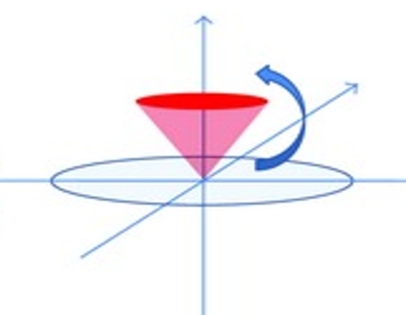

Portion of figure 2 from source: Akila De Silva, Victoria Salem, Paul M. Matthews, Waljit S. Dhillo, [CC BY 4.0](https://creativecommons.org/licenses/by-sa/4.0) (1)

***Example Real-World Application*** Magnetic Resonance Imaging (MRI) can provide lots of diagnostic information in medicine because of the many different contrast mechanisms available. The most common ways of providing contrast to differentiate between different types of tissues involve $T_1$- and $T_2$-weighted images.

## *Expected Learning Outcomes*

*At the end of this module, students should be able to…*

1. *Differentiate and relaxation mechanisms for signal decay (*[*Scientific Ability B9*](https://sites.google.com/site/scientificabilities/rubrics)*)*
2. *Design an application experiment that can determine which sample has longest (*[*Scientific Ability D2*](https://sites.google.com/site/scientificabilities/rubrics)*)*
3. *Choose correct experimental parameters to optimize contrast for different samples (*[*Scientific Ability A4*](https://sites.google.com/site/scientificabilities/rubrics)*)*

**“The direct knowledge of matter that mankind can acquire is a knowledge of the average behaviour and relations of the crowd of molecules.”**

— Joseph Larmor

# Background Information

**relaxation** - the process of a system returning ('relaxing') back to its stable equilibrium state

We have seen that we can control quantum spins by using electromagnetic pulses that can resonate at the spins’ Larmor frequency for a given magnetic field strength. In this module, we explore the other information that can be gleamed from magnetic resonance signal which reflects the behavior of the net magnetic moment of the sample. In particular, looking at how quickly the signal decays away, in a process called **relaxation**, can tell us a lot about the local magnetic environment of our quantum spins.

**time constant** - the time it takes for an exponential decay to reach ~ 0.37 (or 37%) of its initial amplitude

Two primary sources of relaxation are characterized by two different times, and . These times are related to **time constants** one would see in exponential decays of the form . The larger the time constant , the longer it takes for the signal to decay.

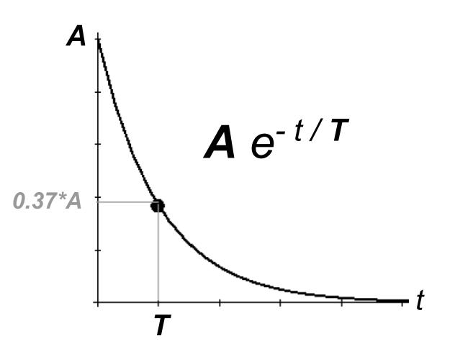

In this module, you will explore the different mechanisms that cause and relaxation, as well as determine how we can design experiments that can make use of these relaxation mechanisms to better characterize our samples.

## Classwide Discussion

* What do you think is meant by ‘local magnetic environment of our quantum spins’?
* What might be contributing to the local magnetic environment of hydrogen-1 (protons) in organic samples (i.e. compounds containing primarily hydrogen and carbon)?
* Which situation do you think would be more likely to cause MR signal decay (relaxation):

1. All the protons see the exact same local magnetic environment
2. All the protons see slightly different local magnetic environments

Explain your choice. *Hint: consider what you would want all the protons to be doing in order to maximize the MR signal.*

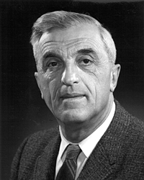**Felix Bloch** - a Physics Nobel Prize winner with Edward Mills Purcell in 1952 for independently developing new ways and methods for nuclear magnetic precision measurements - techniques that would blossom into the field of NMR. When Hitler ascending to power in 1933, Bloch left Germany and came to the United States, where he completed his Nobel-prize-winning work.

“Free imagination is the inestimable prerogative of youth and it must be cherished and guarded as a treasure.”  
- Felix Bloch, [Nobel Prize Banquet Speech](http://nobelprize.org/nobel_prizes/physics/laureates/1952/bloch-speech.html)

Stanford University / Courtesy Stanford News Service, [CC BY 3.0](https://creativecommons.org/licenses/by/3.0), via Wikimedia Commons (2)

# Observation Experiment: Relaxation

In order to uncover the different mechanisms that cause relaxation, let’s return to the [Bloch Simulator](https://www.drcmr.dk/BlochSimulator/) which conveniently has some and control knobs. Let’s see how changing these knobs affects our quantum spins and the measured MR signal.

## Guided Inquiry Questions

1. First, let’s initialize our spin state and then knock the spins down into the x-y plane using a hard- pulse. Is there any MR signal decay? Explain how you came to your conclusion.
2. In the upper-left menu, click on ‘Relaxation: Off’ and you can see that both ‘T1’ and ‘T2’ are set to infinity. Why is having both ‘T1’ and ‘T2’ set to infinity the same as having the relaxation turned ‘off’?
3. Now change the ‘T2’ value to some finite value (while leaving ‘T1’ at infinity). Describe what happens to the net nuclear magnetization vector, , and sketch the resulting plot of and .
4. Describe how relaxation appears to cause the MR signal to decay.

## Relaxation

In NMR, we are always measuring the net nuclear magnetization vector, which is the sum of all the individual magnetic moments of the spins being detected within the sample. If the spins in the sample are experiencing *different local magnetic field environments*, the spins will dephase from each other, causing the net to get smaller and smaller as the individual spins get farther and farther ‘out of step’ with each other. Since this dephasing happens in the transverse (xy) plane, relaxation is also called *transverse relaxation*. These different local magnetic field environments are caused by two common sources: (1) external magnetic field inhomogeneities and (2) magnetic dipole fields from neighboring spins.

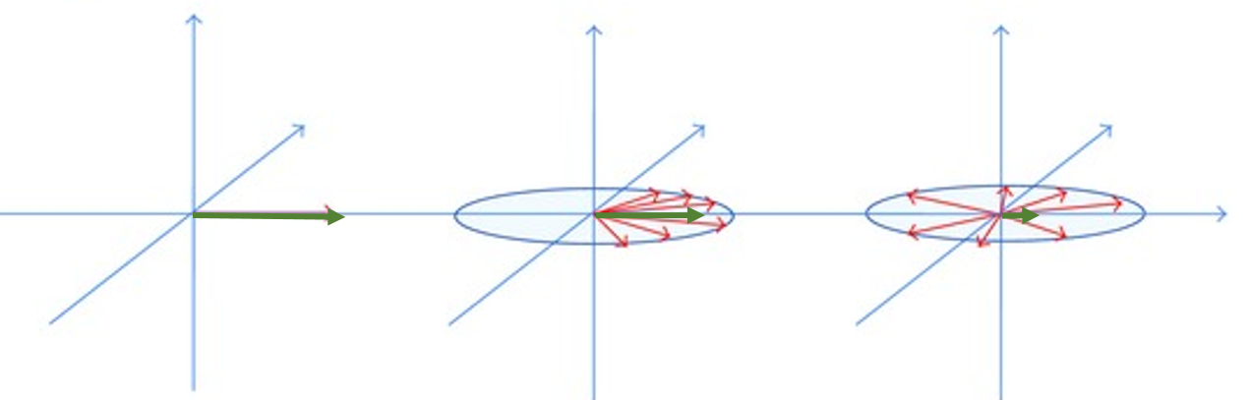

The green arrows signifying the net were added to a portion of figure 2 from source: Akila De Silva, Victoria Salem, Paul M. Matthews, Waljit S. Dhillo, [CC BY 4.0](https://creativecommons.org/licenses/by-sa/4.0) (1)

We saw one example of this relaxation process in the free induction decay, characterized by the time constant . The addition of the asterisk is to highlight that the difference in the local magnetic field environments of the spins is *primarily* caused by external magnetic field inhomogeneities. is not telling us anything particularly useful about our sample, but more about the homogeneity of our external magnetic field.

If, for example, we could completely eliminate external magnetic field inhomogeneities, then we can be confident that the the difference in the local magnetic field environments of the spins is caused solely by the magnetic dipole fields from neighboring spins. The resulting dephasing of the spins and MR signal decay is characterized by (without the asterisk) and encodes helpful information about the strength of the dipolar interactions between the spins within the sample. (At the moment, this may seem more theoretical than practical, but we can actual perform experiments to effectively measure *without* having to make our external magnetic field perfectly homogeneous, but the solution involves some clever uses of pulses that will be explored in the next module.)

Since the relaxation process is primarily due to magnetic interactions between neighboring quantum spins, it is often called *spin-spin relaxation*.

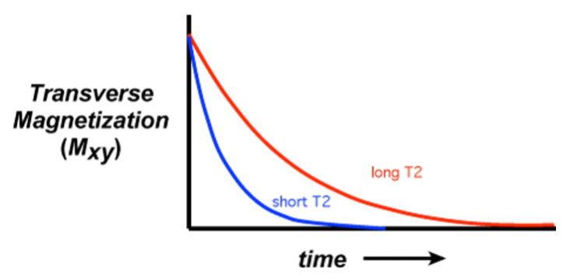

Courtesy of Allen D. Elster, MRIquestions.com (3)

***Relaxation***

* *Spin-spin relaxation or transverse relaxation*
* *Decay of transverse magnetization, (represented by green arrow in figure)*
* *Primarily caused by local magnetic field differences among all the spins in the sample*

## Guided Inquiry Questions

1. Given the description of what causes relaxation versus relaxation, which do you think is always the larger value, or ? Why?
2. Below is some FID data acquired from a mineral oil sample in a 0.5-Tesla magnetic field. What is the approximate value for this sample? *Hint: You want to find the time when the signal reaches 37% of its initial amplitude.*

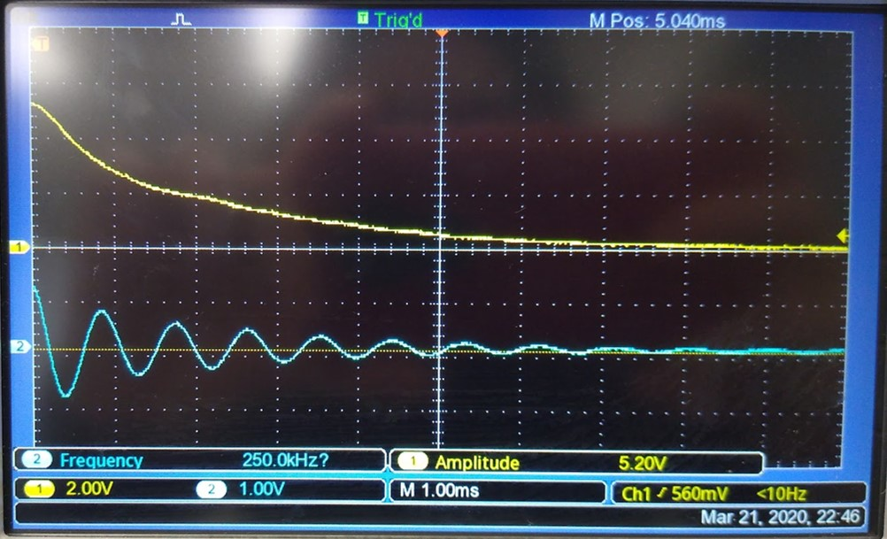

1. If Sample A has a much longer time than Sample B, what can you say about the local magnetic environments of Sample A in comparison to Sample B?

# Observation Experiment: Relaxation

Let’s return to the [Bloch Simulator](https://www.drcmr.dk/BlochSimulator/) to explore the effects of relaxation on the spins in the Bloch sphere representation and how this causes relaxation.

## Guided Inquiry Questions

1. Turn off relaxation (by setting ‘T1’ and ‘T2’ both to infinity), initialize the spin-state, and then knock the spins down into the x-y plane using a hard- pulse. Now change ‘T1’ to some finite value. Observe, sketch, and describe what happens.

*Hint:* It may be helpful to view what is doing during relaxation by checking that box in the 'View' dropdown menu.

1. You may have noticed that it is impossible to set ‘T2’ larger than ‘T1’. This is not a bug in the simulator but turns out to be a physical fact in MR experiments: . That means it may be difficult to fully disentangle the two from each other, but thinking about the difference of the spin dynamics compared with the relaxation observed above, how does relaxation contribute to the decaying MR signal ( and )?
2. If relaxation is also called transverse (xy) relaxation, what might be a good name for relaxation?

## Relaxation

A great video of the and relaxation process can be found on YouTube at <https://www.youtube.com/watch?v=ygwESjbb3rQ>.

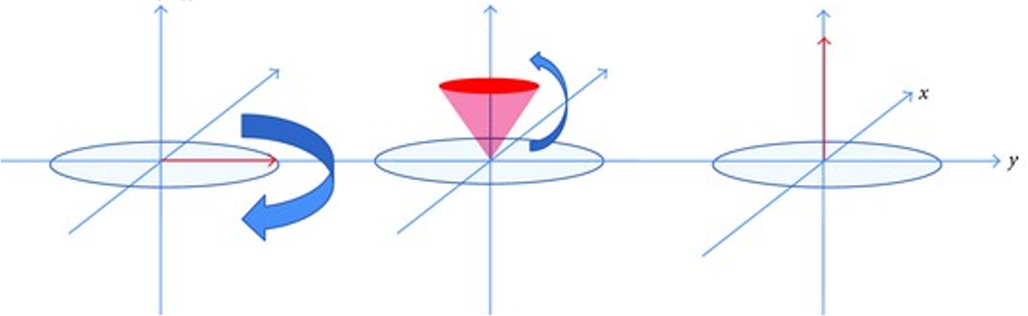

Portion of figure 2 from source: Akila De Silva, Victoria Salem, Paul M. Matthews, Waljit S. Dhillo, [CC BY 4.0](https://creativecommons.org/licenses/by-sa/4.0) (1)

The relaxation process is primarily due to quantum spins exchanging energy with it’s environment in order to return to it’s energetically stable equilibrium state (the state, aligned with the magnetic field along the z-axis). This relaxation process is sometimes instead called *spin-lattice relaxation* (referring to the crystal lattice structure of many solid materials). We know that nature prefers to return to its equilibrium state, and is the time that characterizes how fast quantum spins will naturally return to equilibrium. Many factors determine the time for a sample, most notably the strength of the magnetic field (which determines how much energy is needed to be transferred to transition to the lowest energy state) and the temperature of the sample (which determines how much energy the lattice can potentially exchange with the spin).

The effect of is best viewed by plotting after a pulse has been applied to the spins and watching how fast the signal returns to equilibrium. This follows an exponential recovery curve and longer times leads to a longer recovery. Since relaxation is mostly due to the quantum spins realigning with the external magnetic field along the z-axis, relaxation is also sometimes called *longitudinal relaxation* because the signal is recovering *along* the magnetic field direction.

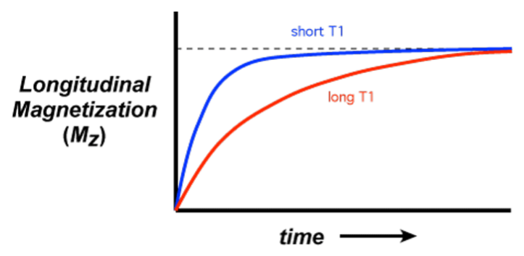

Courtesy of Allen D. Elster, MRIquestions.com (3)

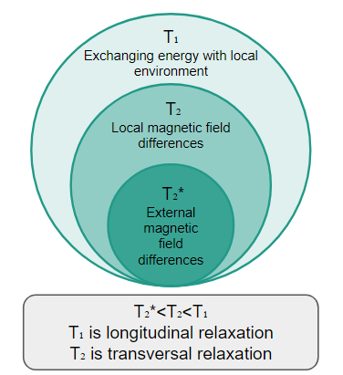

***Relaxation***

* *Spin-lattice relaxation or longitudinal relaxation*
* *Restoration of longitudinal magnetization,*
* *Primarily caused by exchanging energy with local environment*

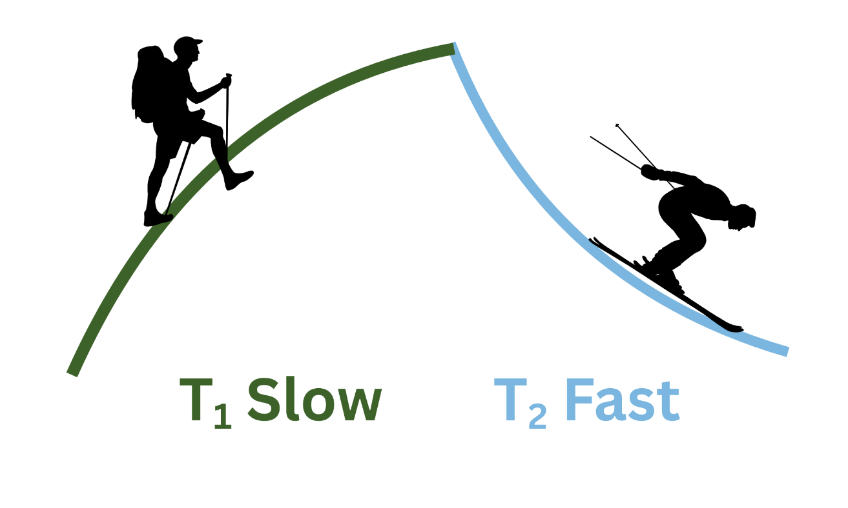Coupling of a - and a -curve resembles a mountain with a slope. It takes longer to climb a mountain than to slide or jump down, which helps to remember that is normally longer than .

## Guided Inquiry Questions

1. Given the description of what causes relaxation versus relaxation, why do you think the time is always longer than ?
2. Describe the magnetic environment that would be necessary for to be equal to .
3. We can only acquire signal along the transverse (xy) plane, but is most easily determined from plotting at different time points. How might we acquire the information? *Hint: The first point of an FID experiment is essentially the value right before the hard- pulse.*

# Chemistry Connections

There are several mechanisms underlying and relaxation that come straight from the chemical structure of the molecule in the sample. A table of the principal relaxation mechanisms are given below, for your reference.

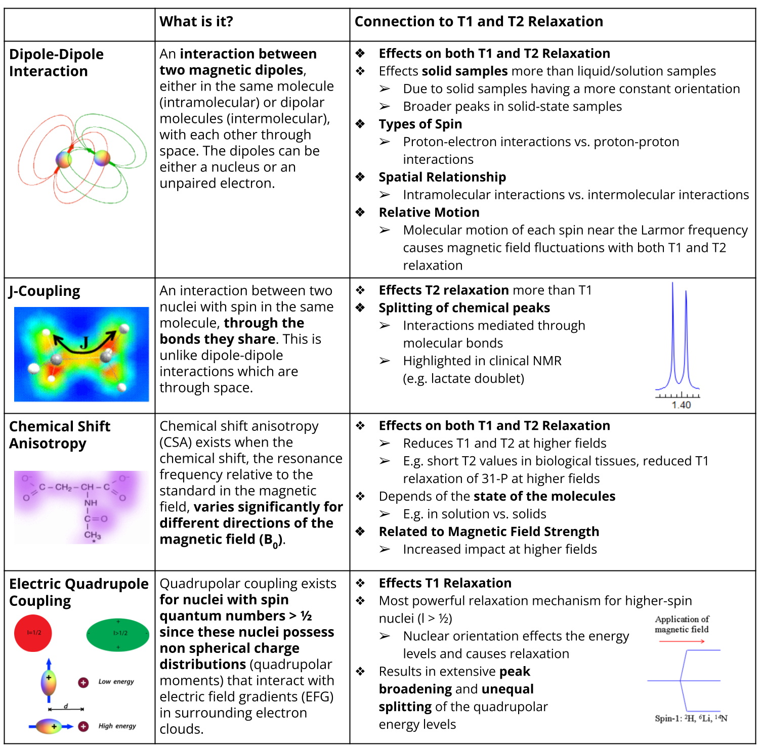

# Application Experiment: Which sample has the longest ?

**pulse sequence** - the time sequence of electromagnetic pulses applied to a sample and the time periods where MR signal is acquired

***Fun fact!*** Due to the sensitivity of the NMR spectrometer receiver, MR signal is never acquired during the transmission of RF pulses. These pulses are typically high-power and would easily overwhelm the detector. Spectrometers that use the same coil for both transmission and receiving have electronics that are very cleverly designed to ensure that the RF pulses (and even the reflections of the pulses) do not make it to the receiver to potentially damage the electronic detection system. If scientists want to view the pulses themselves, they use another detection system (usually simply a small 'pick-up' coil attached to an oscilloscope).

The goal for this activity is for you to develop an experimental procedure to be able to determine which of two samples has the longer time. MR experimental procedures are demonstrated by a **pulse sequence** which shows the timing of application of different pulses and when signal will be acquired. For example, the pulse sequence for the free induction decay experiment is shown below.

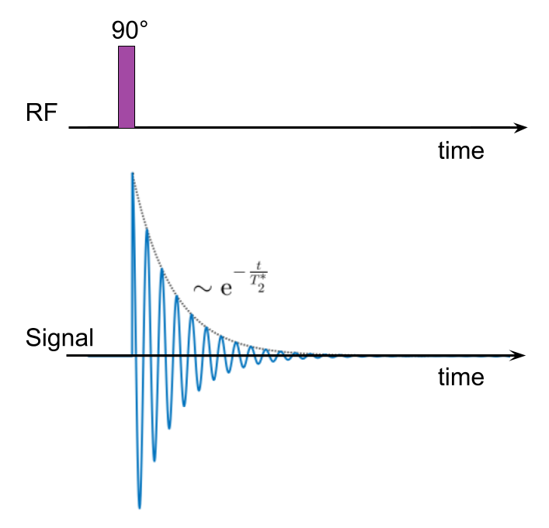

Along with the pulse sequence to provide the timing for transmitting pulses and acquiring signal, MR experimental procedures also include the repetition time (TR) used because most experiments are repeated multiple times so the signal can be averaged together to improve signal-to-noise.

## Guided Inquiry Questions

1. How would the amplitude of the FID change if you ran the experiment with a longer repetition time (TR)? Would a sample with longer time or shorter time have the largest change in amplitude when going from short TR to slightly longer TR times?
2. Describe an experimental procedure you can use to compare the times of two samples. Include a pulse sequence for your experiment/s.

**Once you are happy with your experimental procedure, perform your experiment with the provided samples or check out** [**the experiment we performed and the data we collected**](https://docs.google.com/document/d/1D0tHucSXuKGj0sJl60e_ao_Au3CYdKjPtRVCpo65sLA/edit?usp=sharing) **to determine which sample has the longest time.**

# Reflection Questions

1. What will happen to your MR signal if you choose a repetition time (TR) that is much shorter than the time for your sample?
2. Will using a TR time that is too short impact the measured time?

Below is a plot of the curves for brain tissue compared with cerebrospinal fluid (CSF). You should use this plot to answer the following questions.

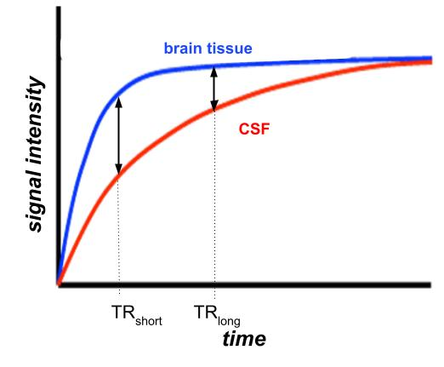

1. Which has the longer time, brain tissue or cerebrospinal fluid?
2. You are designing a -weighted MRI pulse sequence that needs to highlight brain tissue from the surrounding cerebrospinal fluid. Looking at the curves provided, which of the TR times (TR or TR) would be a better choice? Why?

# Supplemental Reading

**What is T1?** <https://mriquestions.com/what-is-t1.html>

**What is T2?** <https://mriquestions.com/what-is-t2.html>

**What are the causes of T1 and T2 relaxation?** <https://mriquestions.com/causes-of-relaxation.html>

## Cited Sources

1. https://onlinelibrary.wiley.com/doi/10.1155/2012/764017 " The use of functional MRI to study appetite control in the CNS"
2. [https://commons.wikimedia.org/wiki/File:Felix_Bloch,_Stanford_University.jpg](https://commons.wikimedia.org/wiki/File:Felix_Bloch,_Stanford_University.jpg%20) “Felix Bloch Portrait, Courtesy Stanford News Service”
3. <https://s.mriquestions.com/opposite-effects-uarrt1-uarrt2.html> “Figures from Questions and Answers in MRI - Opposite effects”